Below are some editable templates of event emails/flyers that you can alter for your upcoming meeting

DO YOU WANT…

DRUG-FREE
PAIN RELIEF?
MORE
ENERGY?
A NEW LEASE
ON LIFE?

NATURAL
SOLUTIONS?

Meet me to find out more:
I’m hosting a launch event to present the amazing, life-transformational benefits of LifeWave patches!
INSERT YOUR PICTURE
Come and hear the inspirational stories of people who have successfully transformed their lives using these phenomenal holistic products. These are drug-free, all-natural products that yield life-changing and sustainable results.

Find out more at my upcoming
Health & Wealth Presentation
Hosted by: _____________________
Date/Time: _____________________

Venue: ________________________

If you cannot attend but would like to learn more about this incredible opportunity, please contact __________ at ____________________________________.

- DRUG-FREE PAIN RELIEF
- MORE ENERGY
- IMPROVED SLEEP
- ENHANCED MOOD
- DECREASED STRESS
?
ARE YOU
READY

Meet me to find out more:
I’m hosting an event to present the amazing, life-changing benefits of LifeWave patches!
INSERT YOUR PICTURE
Come and hear all about these phenomenal products and also how you could make money by sharing them too!

Find out more at my upcoming
Health & Wealth Presentation
Hosted by: _____________________
Date/Time: _____________________
Venue: ________________________

If you cannot attend but would like to learn more about this incredible opportunity, please contact __________ at ____________________________________.

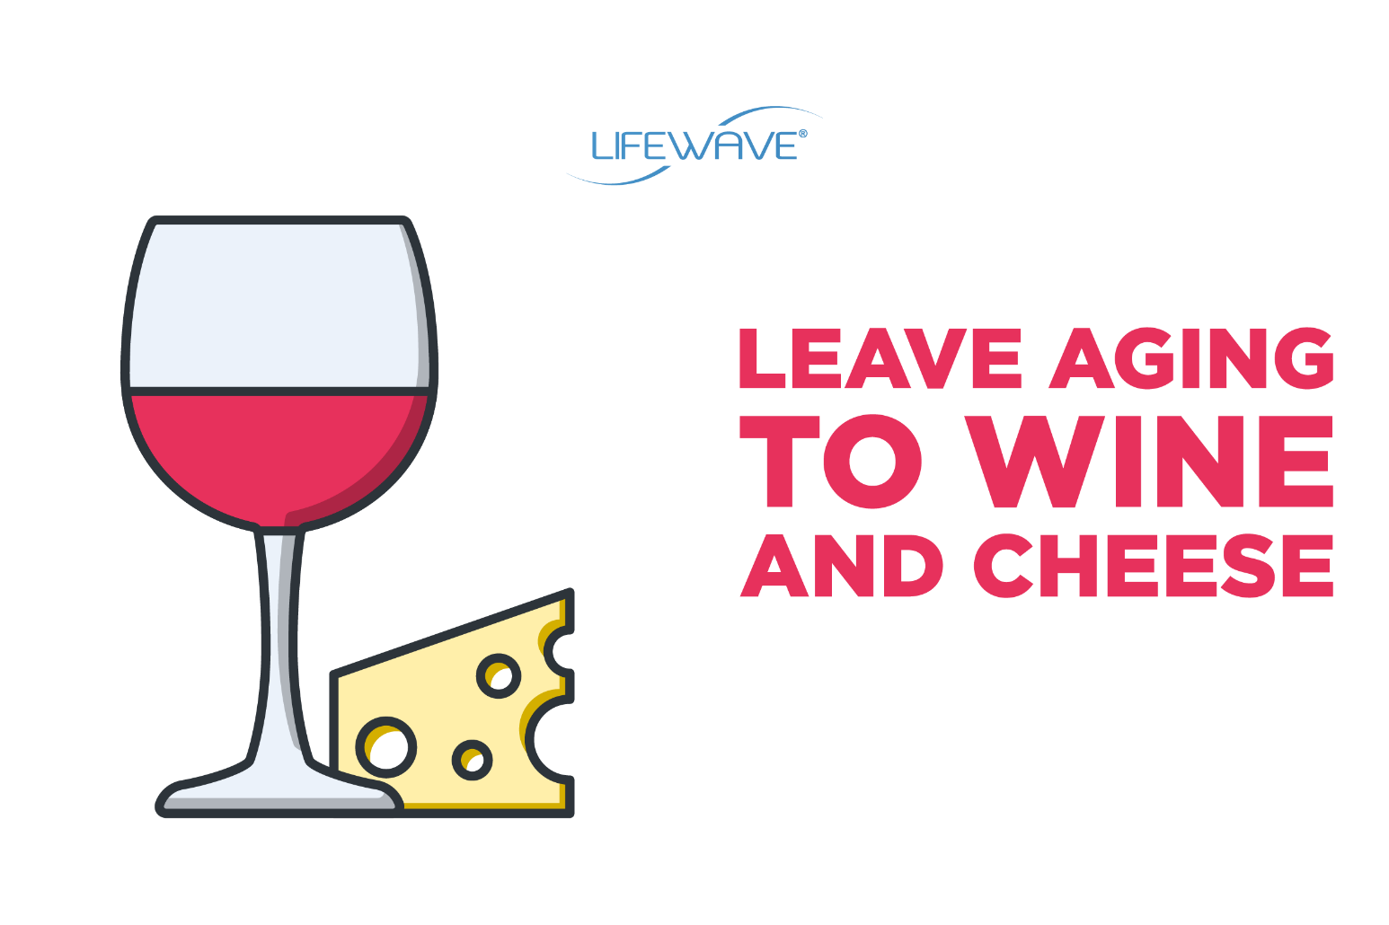

Join us for Cocktails & Conversation!
Enjoy a glass of wine as well as some nibbles while learning how LifeWave will change your life for the better in more ways than one.
Discover Anti-Aging products that will transform the way you look, feel, perform and heal!
VENUE
Date/Time

Please RSVP:
Name | Phone Number
Email Address

Bring a friend for an entry into a draw to win a free product!
If you cannot attend but would like to learn more about this incredible opportunity, please contact __________ at ___________________________________

Start your own business and
EARN WHAT
YOU’RE WORTH!

START EARNING TODAY

- No experience required

- Full Training & Support provided

- Access to powerful, life-changing products

- Work part-time or full-time from home

“INSERT QUOTE”  - XXXX XXXX | Text the word LIFEWAVE followed by your NAME and LOCATION to 000-000-00 in order to register your interest. XXXX will soon be in touch to tell you more about this exciting opportunity and upcoming events.

IT’S TIME TO LIVE THE LIFE
YOU’VE ALWAYS DREAMED OF

AMAZING BENEFITS
- Increased Energy
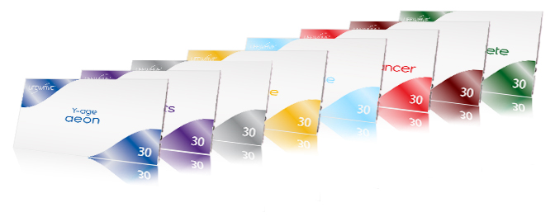
- Drug-Free Pain Relief
- Accelerated Wound Healing
- Improved Sleep

FINANCIAL FREEDOM
- Work from home part-time or full-time
- Work the hours YOU want
- Endless earning potential

LIVE LONG LIVE WELL LIVE YOUNGER

FRIDAY  9th AUG | 0:00  P.M. | Hosted by  YOUR NAME HERE  Address 1, Address 2  Address 3, 0000

